**Exercise 1: Control Structures**

**Scenario 1: The bank wants to apply a discount to loan interest rates for customers above 60 years old.**

**Question: Write a PL/SQL block that loops through all customers, checks their age, and if they are above 60, apply a 1% discount to their current loan interest rates.**Inserting a new Customer value for verification.

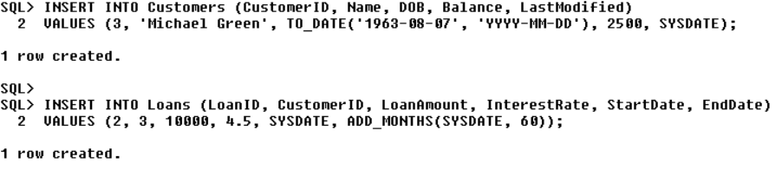

**PLSQL CODE:**

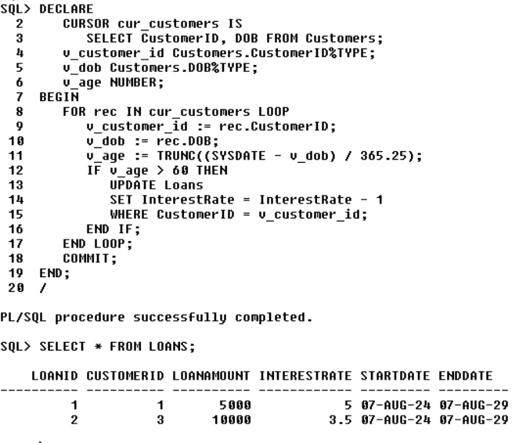

The Interest changed after execution.

**Scenario 2: A customer can be promoted to VIP status based on their balance.**

**Question: Write a PL/SQL block that iterates through all customers and sets a flag IsVIP to TRUE for those with a balance over $10,000.**

Adding a new column and doing the operation accordingly.



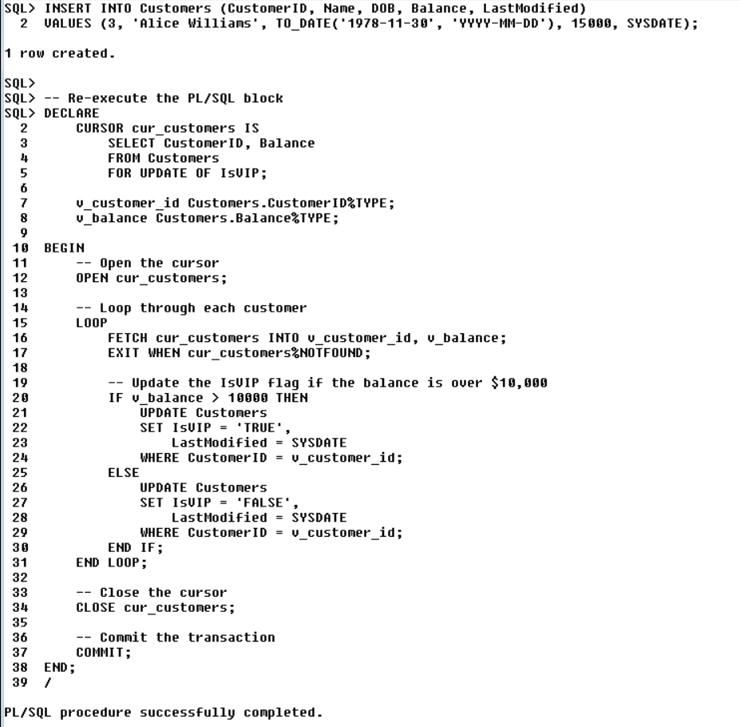

And The output based upon the condition is:

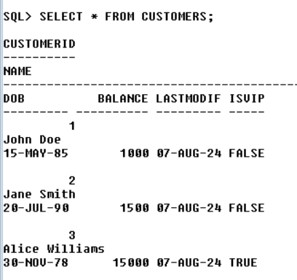

Scenario 3: The bank wants to send reminders to customers whose loans are due within the next 30 days.

o Question: Write a PL/SQL block that fetches all loans due in the next 30 days and prints a reminder message for each customer.

**Step 1: Insert Sample Data**

First, ensure there is data in the Loans table with end dates within the next 30 days. We will insert a loan record for testing purposes.

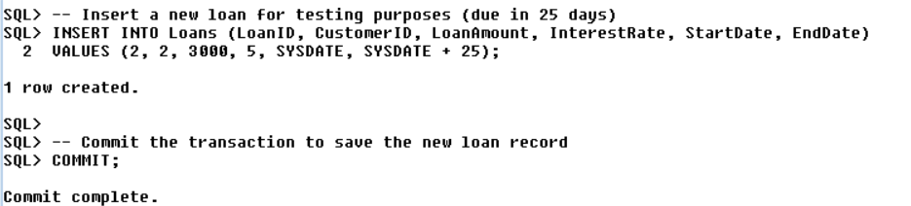

**Step 2: Insert Sample Data**

Now PL/SQL Block for the query is given here.

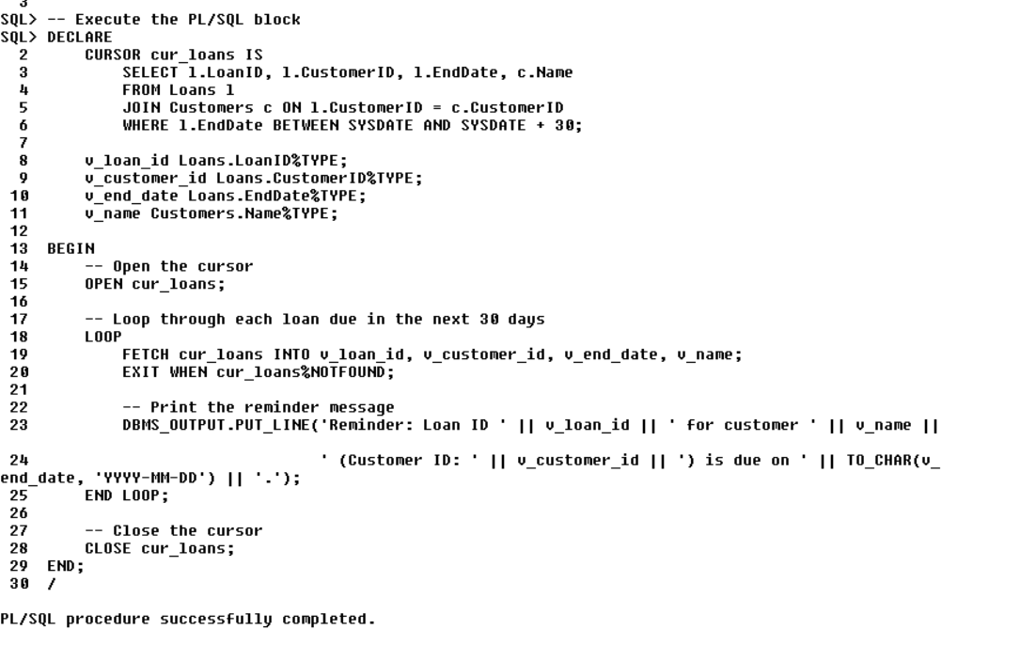

**Step 3: Execution Step**

